**Create a Nested Virtualization Supported Hyper V on Azure**

* Lets create a nested virtualization supported VM on Azure to simulate On-prem Hyperv
* Create a Resource Group  
  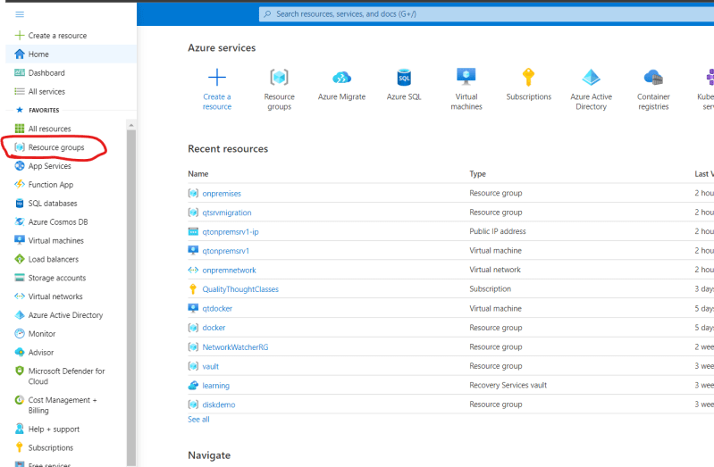  
  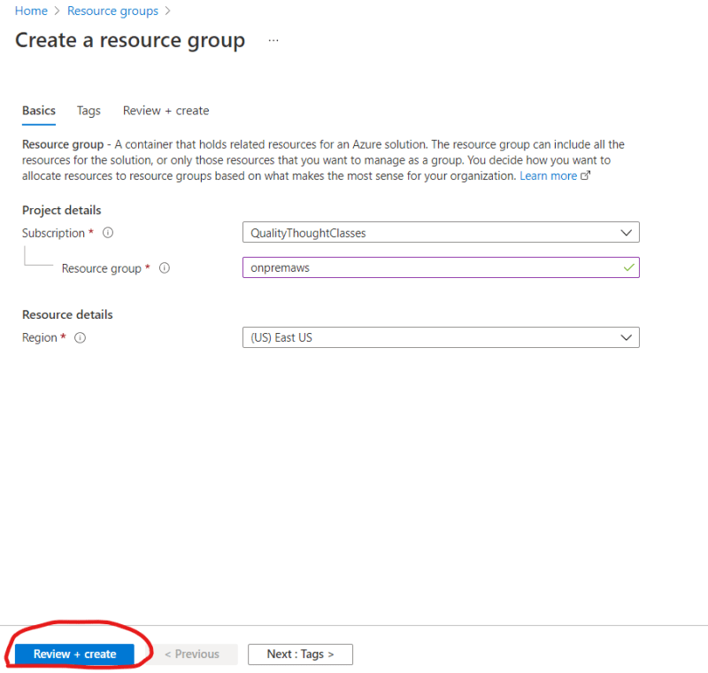
* Now create a Windows 2016 Datacenter Gen1 VM in the created Resource group  
  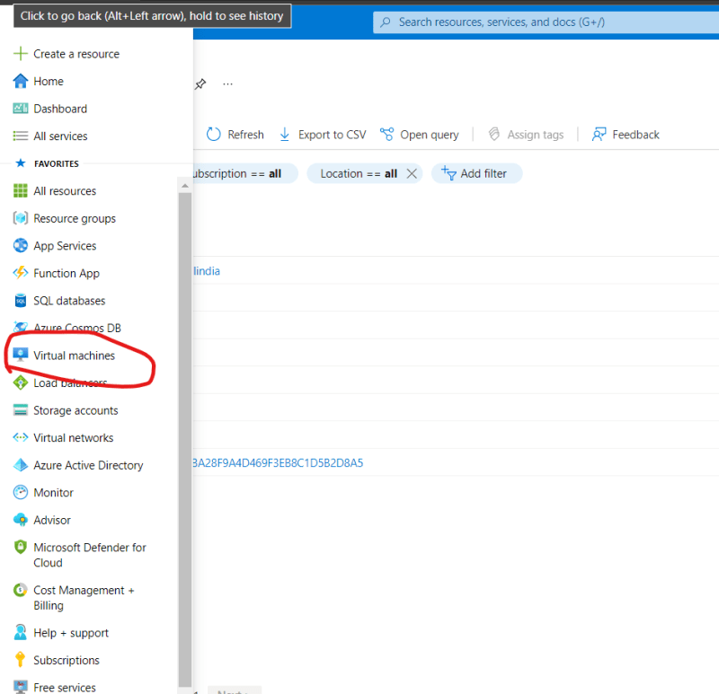  
  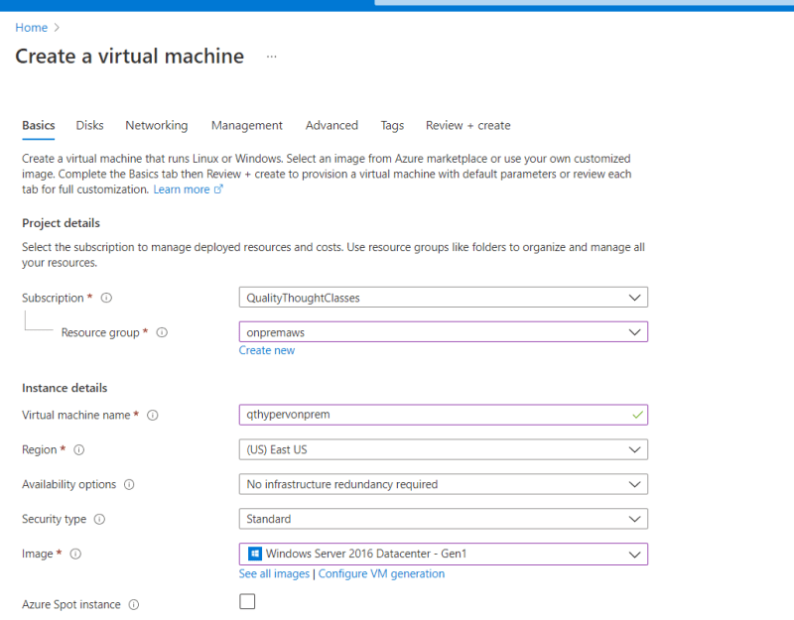  
  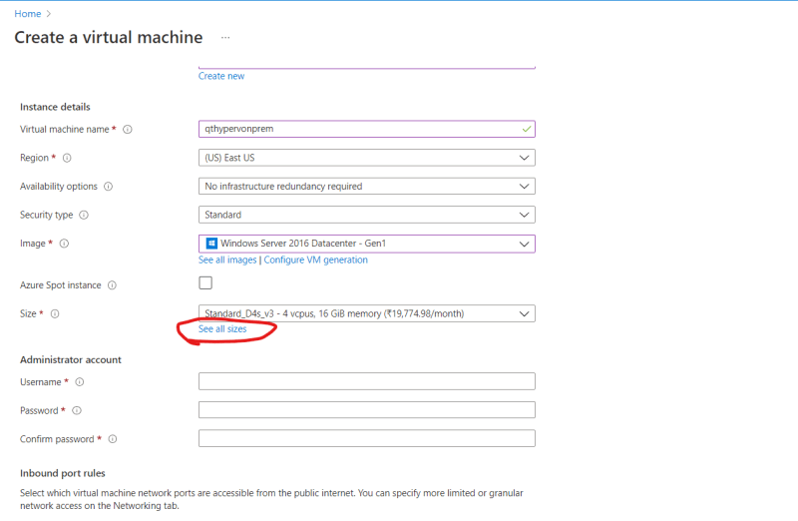  
  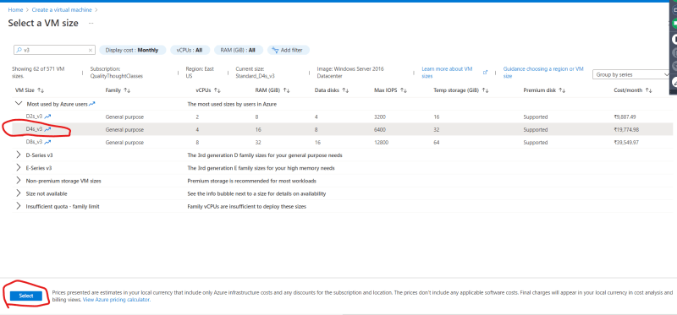  
  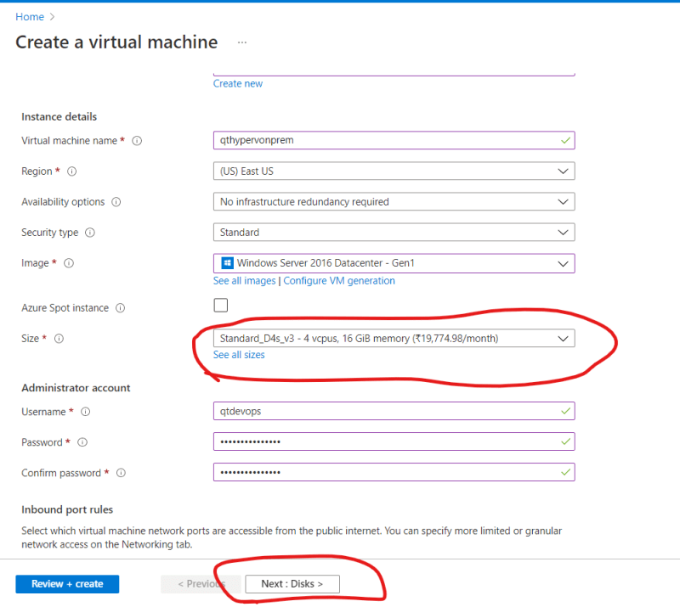  
  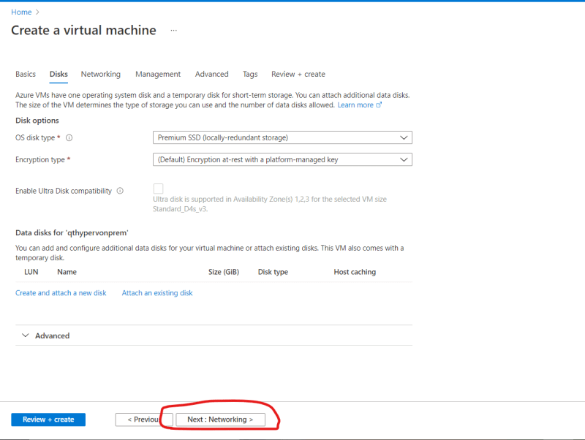
* Create a NSG(like aws security and open all ports)  
  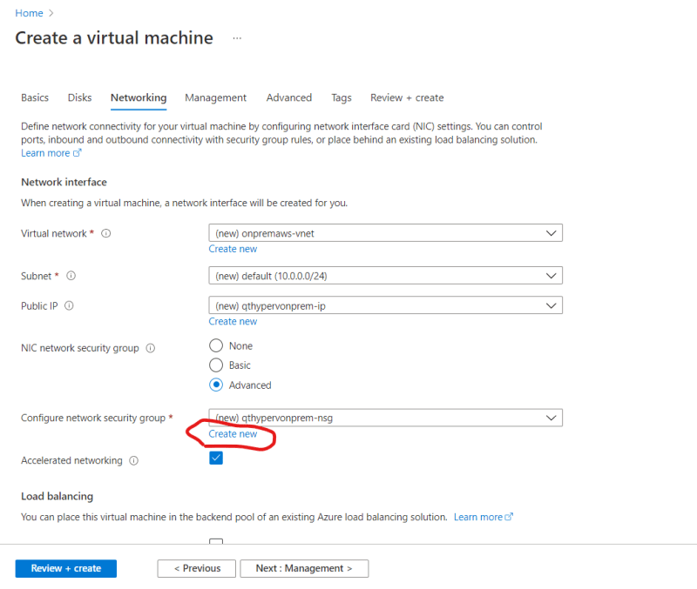  
  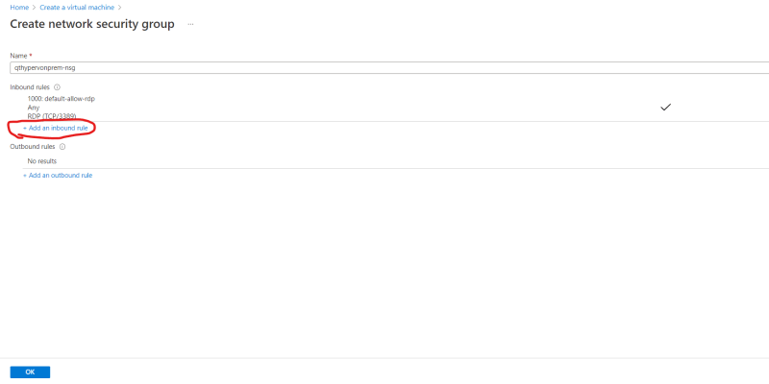  
  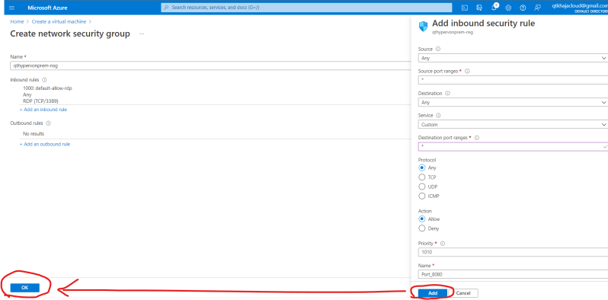  
  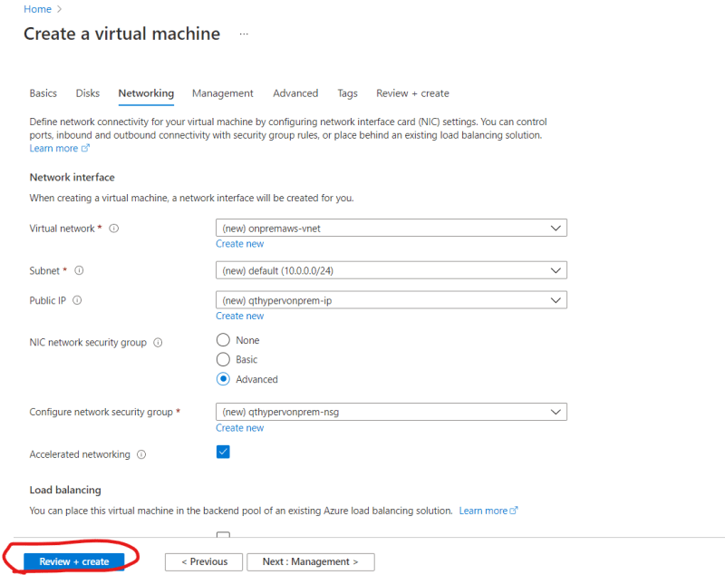  
  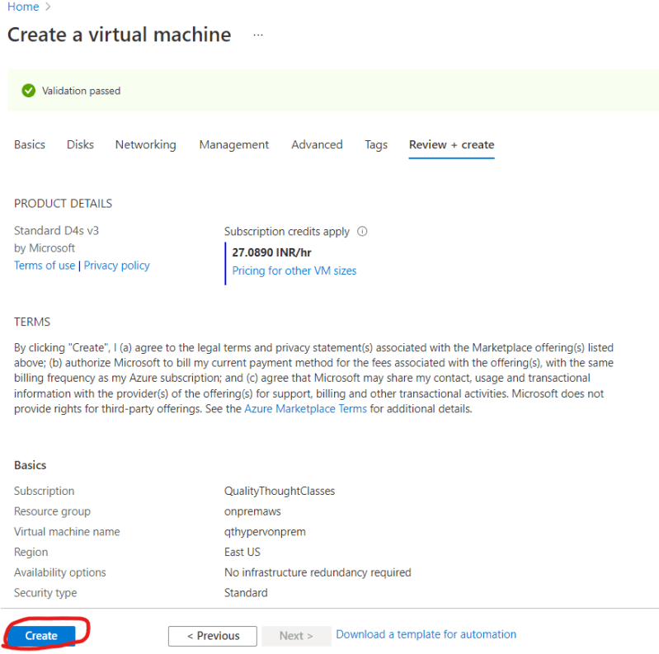  
  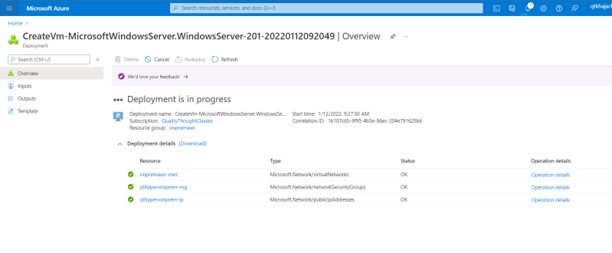  
  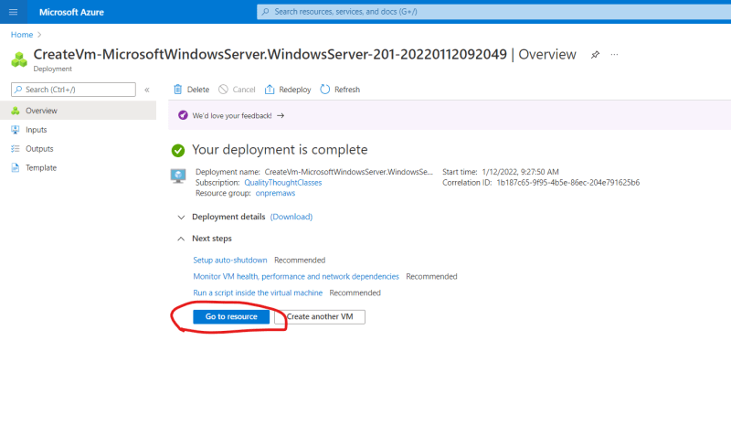
* Once the VM is created, Configure DNS  
  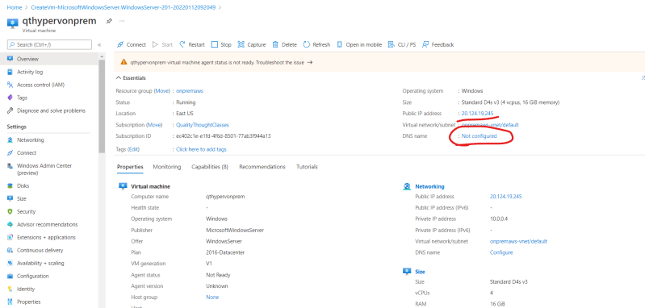  
  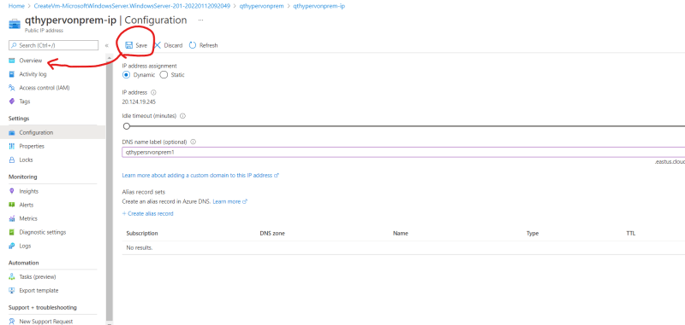
* Now login into Windows server with mstsc -v 20.124.19.245 and wait for the server manager to launch  
  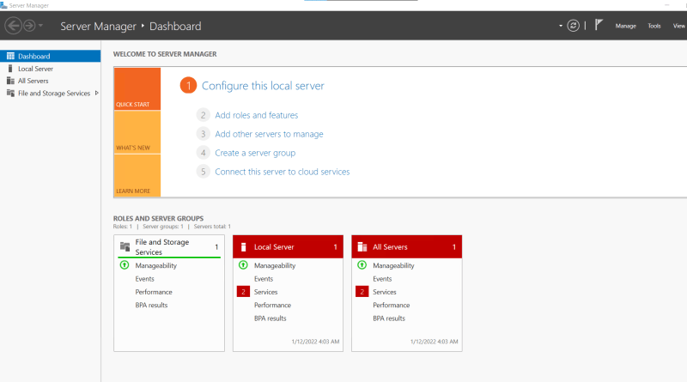
* We can install hyperv using server manager or powershell, I will be using powershell. Launch Powershell as admin & Run the following command which will install hyperv and restart the machine  
  Install-WindowsFeature -Name Hyper-V -IncludeManagementTools -Restart  
  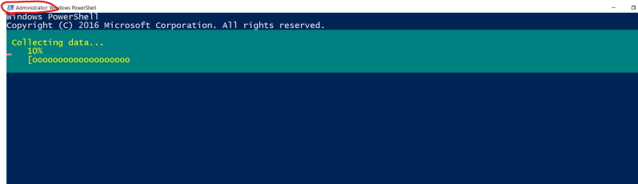
* Wait till the restart is completed and login in using mstsc again. Now you should see hyperv manager in server manager  
  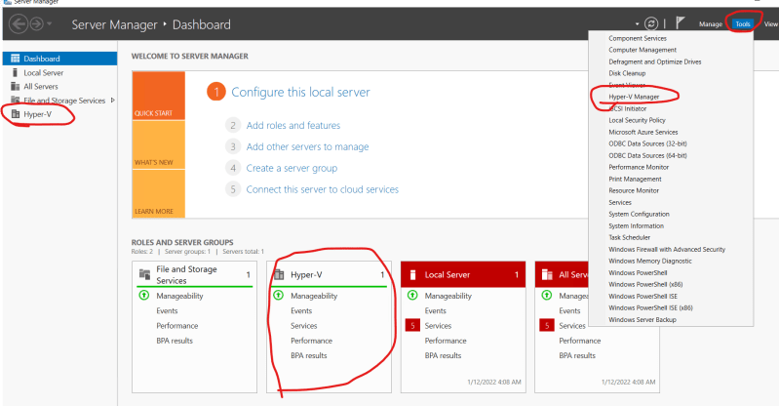
* Now lets try to create an ubuntu 20.04 linux vm using hyper v.
* Download and install google chrome on the windows server and download ubuntu 20.04 image [Refer Here](https://ubuntu.com/download/server)
* Create a virtual Switch as discussed in class
* Lets create a ubuntu vm  
  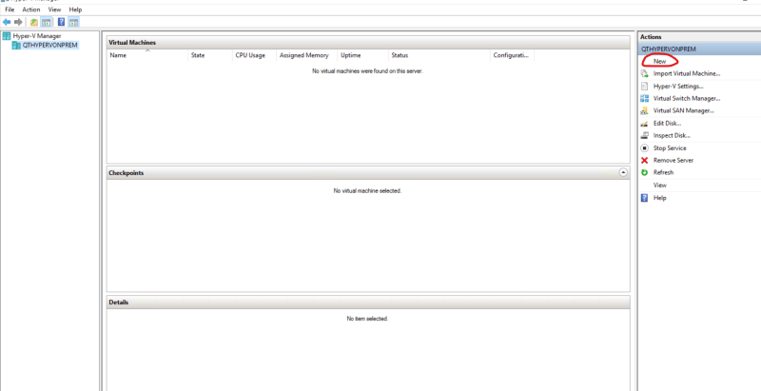  
  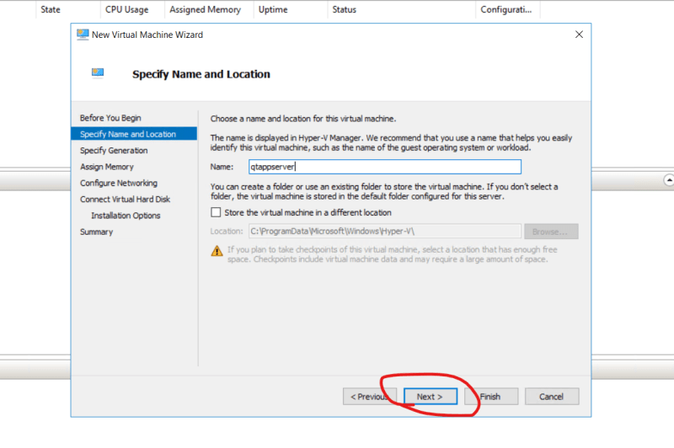  
  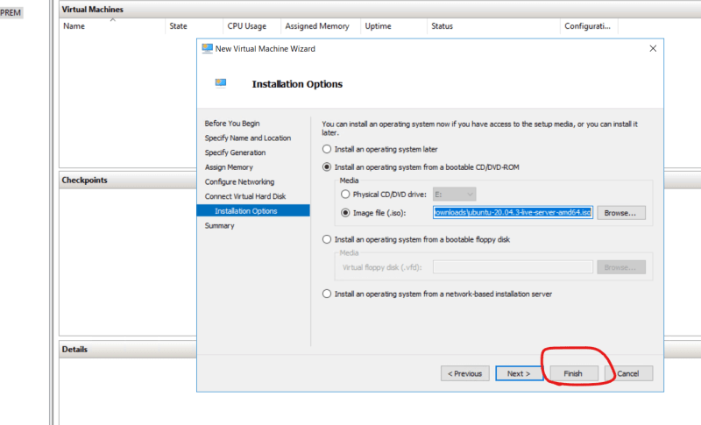  
  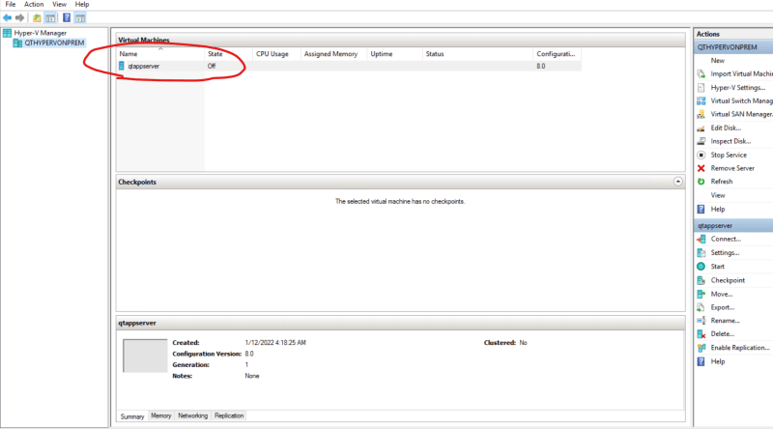
* Double click on the created vm and start the vm
* We would be creating two vms in an automated (manual) fashion inside hyperv and then migrate them to AWS.